|  |
| --- |
| Power BI |
| Introduction to Power BI  Getting Started with Data Visualization |

Imagine you have a giant box filled with information, like sales figures or customer data. This information can be in different places, like on your computer or on a company server.

Power BI is like a special tool that lets you:

* **Open the box and see everything inside:** It can connect to your data, no matter where it's stored.
* **Share your findings with others:** You can create clear and interactive reports, like charts and graphs, to show your insights to colleagues or your entire organization.

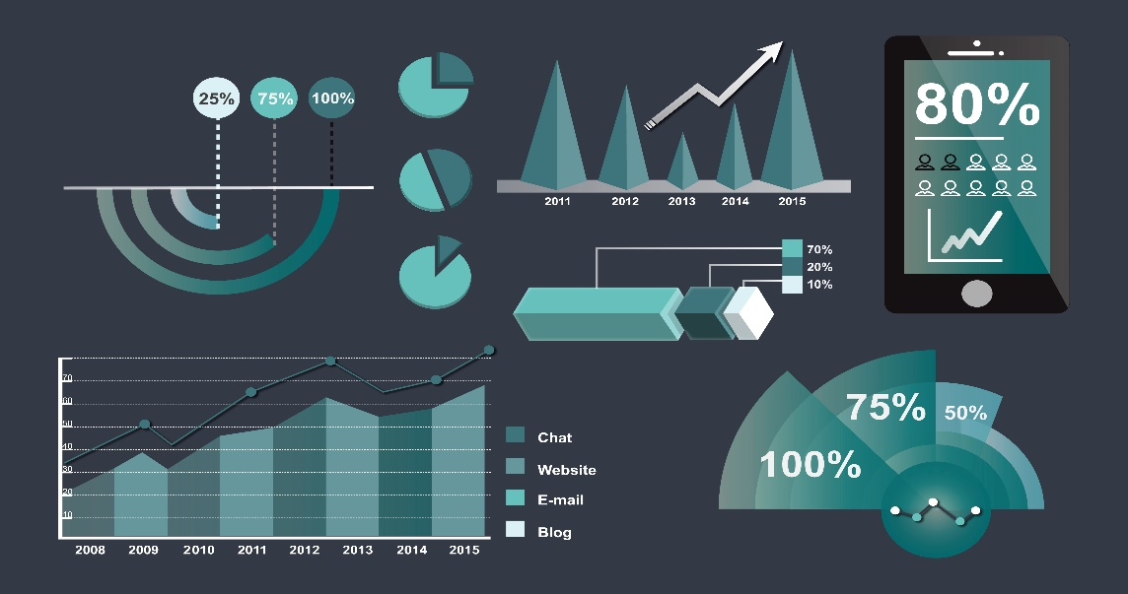

* **Make sense of the information:** It helps you organize and analyze the data, so you can easily understand it.
* **Work together on the data:** Everyone can access and interact with the reports, making it easier to collaborate and make decisions.



So, Power BI basically helps you **unlock and explore your data**, **share insights easily**, and **work together** to make better decisions.

**Advantages of Power BI**

* **See everything clearly:** Organize the papers and turn them into colourful charts and graphs, making the information **easy to understand**.
* **Work together easily:** Share these clear pictures with anyone, so everyone is on the same page and can **discuss and decide together**.
* **Access information anytime, anywhere:** Get the insights you need, even on your phone, so you can **make quick decisions** no matter where you are.

### 

### **Power BI Components**

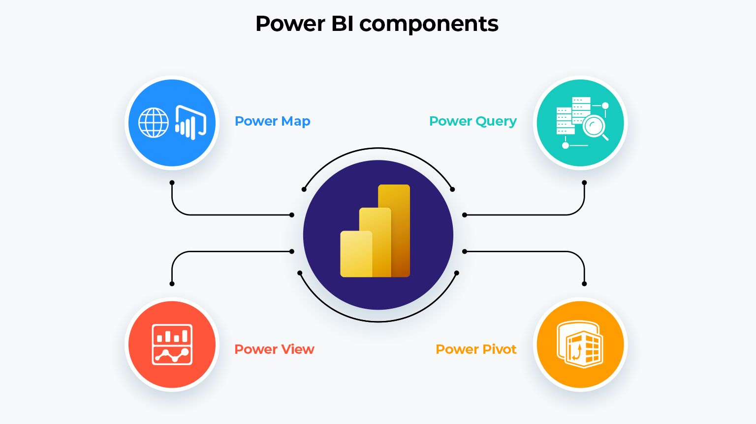

Imagine you have a big box of Legos (your data), but they're all mixed up. Power BI has different tools to help:

* **Power Query:** Like a **super vacuum**, it sucks up your data from anywhere.
* **Power Pivot:** Like a **master builder**, it organizes your data to make sense.
* **Power View:** Like a **colourful storyteller**, it uses charts and pictures to show what you built with your data insights.
* **Power Map** (not in the newest version)**:** Like a **special map builder**, it shows your data on a map to see cool location patterns.

### **Installation**

Power BI only runs on Windows Machines. Mac users can use Windows VM in Azure or use [**Turbo.net**](https://app.turbo.net/run/powerbi/powerbi), which can stream Power BI to the Mac directly from the cloud.

This is the first step to go into Power BI

According to your needs, you can download the software on your computer. After all agreement, verify the installation by clicking the Power BI Icon.

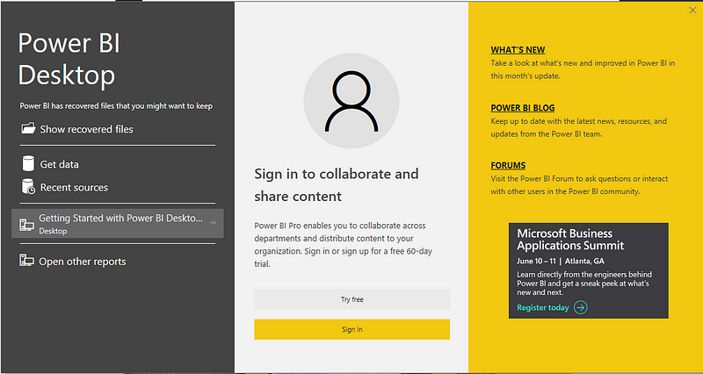

### **Power BI Workspace**

Power BI workspace is Like a shared folder for your team to work together on data analysis projects in Power BI.



## **Conclusion**

Power BI is like a **magic tool** that helps you **unlock the secrets hidden in your data**. It transforms confusing numbers and spreadsheets into **clear pictures and charts**, making it easy to **understand what your data is saying**. So, if you want to **make better decisions based on real information**, Power BI is your key.

**References**

Datacamp: <https://www.datacamp.com/tutorial/data-visualisation-powerbi>

Beyondkey: <https://www.beyondkey.com/blog/what-is-power-bi/>

1000logos: <https://1000logos.net/microsoft-power-bi-logo/>